Cambian Group
Cambian Autism Services Ltd

Statement of Purpose

Paddocks View
Address: Paddocks View, Shillingstone, Blandford Forum, Dorset, DT11 0QS

Tel: 01258 860295

Ofsted Number: 2836211

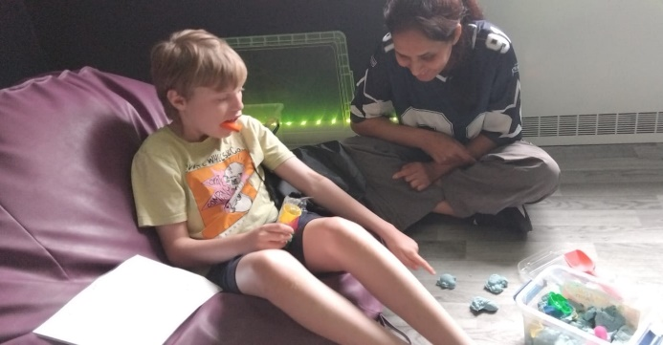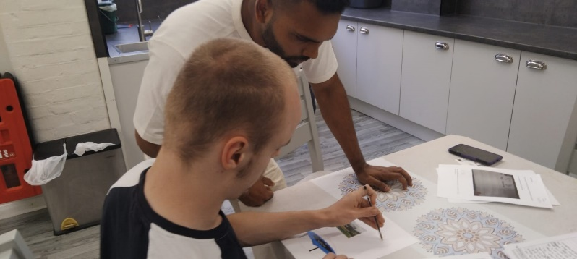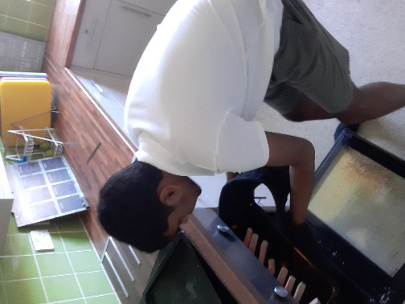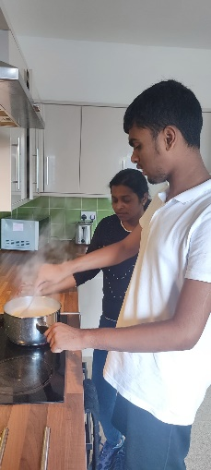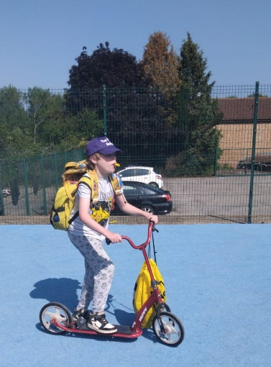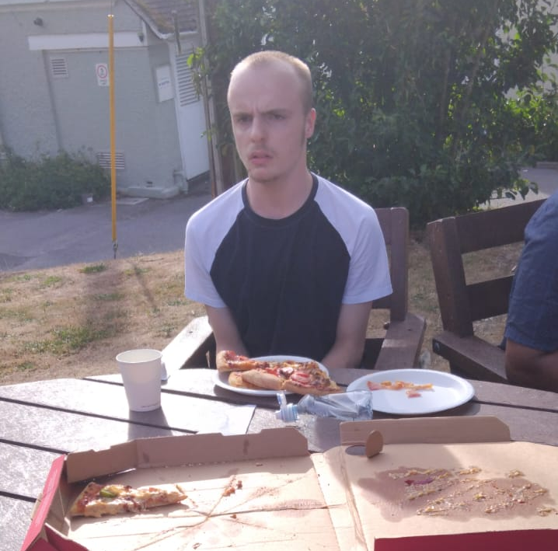

Paddocks View

Matters included in this Statement of Purpose:

QUALITY AND PURPOSE OF CARE

A statement of the range of needs of the children for whom it is intended that the children’s home is to provide care and accommodation.
Paddocks View is registered to support and care for up to 13 young people from 7 to 19 years old, who are experiencing difficulties as a result of a diagnosis of Autism and secondary conditions such as, but not limited to, Attachment Disorder, Attention Deficit Hyperactivity Disorder (ADHD), Oppositional Defiant Disorder (ODD), Pathological Demand Avoidance (PDA), Anxiety, Obsessive Compulsive Disorder (OCD), Epilepsy and Diabetes.

Young people have cognitive abilities within the moderate/severe learning disabilities range and all demonstrate difficulties in a range of key areas of development affecting everyday life and have significant support needs. These difficulties may include social understanding and communication, flexibility, coordination and sequencing, attention and concentration and repetitive and obsessive behaviours. Most young people also experience global or specific learning difficulties of a severe to moderate nature. There may be additional needs around mental and emotional health, such as self-harm and self-neglect. Behaviour may be challenging and can include aggressive and/or sexualised behaviour and some young people may exhibit behaviour in an attempt to control their environment or the people in it.

Young people come into Paddocks View when their identified and assessed needs can be met and they are compatible with the needs of the existing young people which is detailed in their ‘Compatibility Risk Assessment’ prior to admission. All young people will have an Education Health and Care Plan (EHCP).

Details of the home’s ethos, the outcomes that the home seeks to achieve and its approach to achieving them.
‘To actively enable each and every one of the young people in our care to achieve their personal best, however it is defined by them or for them.’

We believe that young people in our care should have access to a calm, consistent, nurturing approach to meet their very individual needs and address their diagnosis. In order to achieve their full potential, we must have high but realistic and meaningful expectations and an open, honest partnership with parents and all associated professionals.

Communication is the key to all of our work and all adults are asked to respect each young person’s individual communication style. All methods of communication are encouraged and valued, to enable our young people to understand and be understood.

Approaches to Autism are many and varied. As a home we are child-centred and believe that by taking an eclectic approach we can provide young people with an individualised program to suit their own specific needs.

We engage with the wider community and seek to consult and keep parents, guardians, authorities and stakeholders fully informed and updated.

We are positive and motivating, offering choices of activities and ensuring they are motivating and fun. We positively encourage and role model to show our young people that new experiences and social situations are not as confusing or frightening as they may first appear to them. Young people are consulted about their preferences around the activities that they are offered and these views are taking into account when planning their leisure time.

The ultimate goal of the home is to support our young people, through specialist approaches, appropriate environments and adult expertise, to ensure they are fully supported following arrival, and then to enable them to strengthen their skills and gain new ones to encourage and foster independence and a sense of achievement. We do this through providing a stable environment in which each and every young person is able to build positive relationships with both the adults that support them and the other young people with whom they live. This supports the young person to engage with education, reduce risk with increased awareness, help them to develop and express their views wishes and feelings and improve their psychological and emotional well-being.

The home aims to support young people to prepare them to meet the demands of everyday life for a positive transition from Paddocks View into adult life. We want young people to live as independently as possible, making decisions about their lives and having a degree of autonomy commensurate with their wishes, aspirations and abilities.

Additionally, we aim to provide a supportive, therapeutically-informed environment and a range of opportunities within which young people can develop self-esteem, self-advocacy, personal dignity, confidence and maturity leading to an optimum quality of life.

All the work we do is underpinned by a belief that all the children and young people in our care should feel genuine warmth and love. We aim to show love through careful consideration of the things we do and the things we choose not to do whilst supporting and educating the children and young people. Our ultimate aim is that when the children leave our home and reflect on their time with us, they do so positively.

The home has comprehensive assessment systems which measure progress across Education, Care and Therapeutic provisions in a holistic way. The home works collaboratively with School and the therapy team during each young persons time with us to ensure that each department has a clear understanding of progress both with educational targets and those relating to life and living skills and that goals that are set are both achievable and relevant while providing the right level of ‘challenge’ in terms of development for each young person

A range of assessments are completed by the team at Paddocks View in collaboration with clinicians and assistants from the therapeutic disciplines to inform the basis of individualised plans designed to meet specific needs. These plans form the basis of the three-way partnership between young person, family and other relevant parties in order to strengthen the skills of the young person. Assessment may include:

- Behaviour watch – to pool data on young person incidents looking at severity, frequency and trends and patterns of data.
- Music Therapy – following assessment, programs devised by therapist on an individual basis
- Psychology – assessment of cognitive, behavioural and mental health needs
- Speech and Language Therapy – assessment of social communication
- Occupational Therapy – assessment of activities of daily living and sensory needs
- Equine Therapy – baseline assessment and then individual programs devised

Assessments are shared with parents and other professionals in a timely manner as appropriate to each individual. The multi-disciplinary team work together to provide baseline assessments as needed upon the young person’s admission, through the 12-week assessment period and then individual programs are drawn up and shared across the adult teams as required to support strengthening of skills.

Further support for the young person is provided through:

- Positive Behaviour Support Plan (PBSP)
- Individual Risk Assessment (IRA)
- Communication Plan
- Sensory Plan
- Community Access Plan
- Physical Security and Restrictions Overview
- Ongoing Compatibility Risk Assessment
- Medical assessments – overseen by the Registered Manager – medical and well-being needs continually reviewed in consultation with Consultant Paediatrician, GP, Consultant Psychologist and Consultant Psychiatrist
- Ophthalmic Needs are monitored and provided by the local community Optician – frequency is determined by the Optician on an individual basis
- Dental Needs are monitored and provided by the Special Care Dentistry Unit based at Dorchester Hospital. This service is either provided by the professional visiting the school to carry out examinations or the young people access the community hospital or dental surgery as necessary – frequency is determined by the Dentist on an individual basis

Supervision of the young people is of paramount importance. Risk assessments have been written for all activities and each young person has any risks identified in their Individual Risk Assessment (IRA). There is a Compatibility Risk Assessment as well as a ‘Physical Securities and Restrictions Overview’ for each young person. There may also be other young person specific risk assessments related to individual circumstances. An annual review of the Health and Safety Risk Assessment (HSRA) and Fire Risk Assessment (FRA) of the home is completed annually.

A description of the accommodation offered by the home, including—

How accommodation has been adapted to the needs of children;
Paddocks View is set in extensive grounds - leisure facilities include occupational therapy room, a theatre, indoor heated swimming pool, sports hall with interactive sports wall, climbing wall, bouncy castle, trampolines, play equipment, sensory room, sensory/relaxation rooms or areas within the home, indoor/outdoor horse riding, stables, cycle area, playground, walks in the grounds.

Safety of our young people is of paramount importance and is maintained in a variety of ways balancing this against working to ensure that environments are homely and welcoming. Any physical restriction that occurs, including locks and keypads is carefully considered with the balance of independence, safety and risk at the forefront of any decision. The home always wish to reduce any restrictions including keypads, however always balance this against the safety and risk for our young people, so this is kept under constant review and underpinned in a number of situations by the Mental Capacity Act’s least restrictive practice principles.

The young person, their parents, social workers and any other stakeholders are consulted in relation to their specific needs prior to admission at a planned pre-admission meeting. At this time, matters relating to personal preferences or additional adaptations can be highlighted, discussed and planned and any choices made in relation to the young person’s belongings. Where appropriate other considerations such as décor of their bedroom can also be discussed however given the level of understanding of our young people this is often a piece of work that is done with a young person after their admission to the home.

For existing young people this will continue to be ongoing and taken into consideration as part of any planned internal transition. Examples of adaptations may include, sensory resources, privacy screens if necessary and any other necessary restrictions; all of which are discussed, risk assessed, agreed, documented and regularly reviewed. The home works with relevant others in relation to the Deprivation of Liberties (DoLS) for any young person.

The age range, number and sex of children for whom it is intended that accommodation is to be provided; and
Paddocks View can accommodate up to 13 young people between the ages of 7 and 19 years. Young people may continue to reside with us beyond 18 if:

- this reflects the requirements of a young person’s Education Health and Care Plan (EHCP)
- there is a plan in place for the young person, created by their social worker, that clearly demonstrates a ‘moving on’ process and the Registered Manager has completed a risk assessment that demonstrates that the other children in the home/school will not be at risk by living with an adult. The Registered Manager will ensure that numbers of young people aged 18 and over are kept below half the amount of places within a 12 month period and are included in the numbers that Paddocks View is registered for in line with the “wholly or mainly” requirement.

The type of accommodation, including sleeping accommodation.
The living accommodation at Paddocks View is arranged across 3 individual homes Willows, Cottage and Hambledon .
Our accommodation availability ranges from 38 week to 52 week and the different homes offer different types of accommodation. Homes are chosen for young people according to their individual needs and in relation to compatibility with the other young people living in the home.

Hambledon – is a 6-bed home with a ground floor living area and bedrooms on the first floor. Young people have access to their own garden area.

Willows – is a 2 bed home consisting of a lounge, kitchen, bedroom and bathroom on the ground floor with a further bedroom and bathroom on the first floor. Young people have access to their own garden.

The Cottage – This is a 5 bed home with a large communal kitchen on the ground floor. The lounge , dining room, sensory room and laundry facilities on the lower ground floor and bedrooms on the first floor. This home has access to its own garden.

Every young person has his or her own room and rooms may have either a vanity unit or an en-suite bathroom (unless there is a particular request/need for this not to be the case, based on risk and/or individual needs.) Accommodation will be adapted to suit the needs of a young person where practically possible; some young people may, through sensory sensitivity, require a low stimulus environment and they will be supported with this.

Young people and their families are encouraged to personalise rooms with photographs, books, toys and other items from home. There are several safe outside play areas which are available to each home and include swings and play equipment. Young people have adequate storage space for personal belongings and the right to privacy in their own bedrooms. Any young person who wishes to and is able to manage this, can have a lock on their bedroom door as well as being able to have lockable storage in their rooms.

A description of the location of the home.
Paddocks View sits within the site of The Forum School which is situated in the village of Shillingstone in Dorset. It is about 5 miles north-west of Blandford Forum which is the nearest town. The school occupies a 28-acre site which includes formal garden areas, , an indoor swimming pool, a cycle track, a sensory garden and a curriculum trail that winds around various curriculum specific and sensory areas.

Links and contacts with the local community are an essential part of the daily life of our young people. Young people access local amenities such as the shop or garage within the village and are able to travel the short distance to Blandford to be able to access the high street, swimming pool, library, parks, restaurants and supermarkets.

The area has been risk assessed as a suitable low risk location for a children’s home.

The arrangements for supporting the cultural, linguistic and religious needs of children.
We recognise and respect our individuals’ religious beliefs, customs, rituals, religions, cultures and linguistic needs and will fully support their needs, wishes and preferences. Initial information for each young person is gained from them, their parents and other stakeholders at the pre-admission meeting.

The school and home believe that young people should have the opportunity to maintain, observe and celebrate their religious and cultural identity. The home acknowledges different religious beliefs, cultures and traditions. Adults will encourage young people in their religious and cultural needs, for example, by taking a young person to a place of worship, by supporting the young person to participate in daily prayers, by supporting young people to light candles if this relates to their beliefs, by supporting participation in their religious celebrations and/or where appropriate by ensuring dietary requirements are supported.

Many of our young people have communication difficulties; they are supported with these difficulties using visual supports which may include symbols, pictures, an electronic device, drawn pictures or written information. In the situation where a young person’s first language is not English, we would consider the appropriateness of providing communication symbols displaying both languages; this would be dependent on the individual needs for this.

Details of who to contact if a person has a complaint about the home and how that person can access the home’s complaints policy
Paddocks View operates a complaints policy and procedure in accordance with the details set out in the Cambian Group Complaints Policy; this is available on the home’s network and website. Complaints are brought to the Responsible Individual or Registered Manager who ensure that all complaints are recorded in the complaint log. This record includes all correspondence and resolution. Paddocks View seeks to gain the views of the complainant once a complaint is finalised. This record is reviewed by the Registered Manager/Responsible Individual and the Independent Person as part of the Regulation 44 of the Children’s Homes Regulations and Quality Standards 2015 visit.

We believe that any young person has a right to have their views heard or make any comment about their home or the education they receive. The Young People’s guide refers to how to complain and all young people have an individualised copy of this.

If you have a complaint about Paddocks View, please contact the responsible Individual, Melissa McCarthy and/or the Registered Manager, Mark Rogers at:

Paddocks View
The Forum School
Shillingstone,
Blandford Forum,
Dorset,
DT11 0QS

Tel: 01258 860295
Email: Melissa.McCarthy@cambiangroup.com or Mark.Rogers@cambiangroup.com

If your complaint is regarding the Registered Manager, Mark Rogers, then please contact Melissa McCarthy, Responsible Individual on the email address Melissa.McCarthy@cambiangroup.com

If your complaint is regarding the Responsible Individual, Melissa McCarthy, please contact the Operations Director Care SEN
Email: Graham.norris@cambiangroup.com

Independent Advocate: 0151 649 8700

Children’s Rights Officer: 0800 5280731

Ofsted: 0300 1234666
Children’s Commissioner
Address; The Office of the Children's Commissioner Sanctuary Buildings 20 Great Smith Street London SW1P 3BT.
Tel: 020 7783 8330

Alternatively, a complaint can be made to any adult or any other professionals including our health and education team that are involved in the care for the young person.

You may request a copy of the Complaints Policy at any time.

Details of how a person, body or organisation involved in the care or protection of a child can access the home’s child protection policies or the behaviour support policy.
Cambian takes a very active stance on whistle blowing. The safety of young people is the paramount consideration of the Company and subsequently adults are equipped and encouraged to report concerns and inappropriate practices to outside agencies when it is felt that they have not or cannot be successfully managed within the Company.

The Safeguarding and Behaviour Support policies and procedures are available upon request, in a variety of formats; all adults have access to them. These can also be accessed via the companies’ website.

Mark Rogers the Registered Manager is also responsible for the oversight of any safeguarding concerns With the support of Melissa McCarthy the Responsible Individual There are also other Senior Managers who support with Safeguarding at Paddocks View as listed below:

Mark Rogers Registered Manager Tel 07525 632629
Melissa McCarthy Responsible Individual Tel 07917 048872
Kerry Byron Head of Care Tel 07525 629525
Hannah Everard Care Manager Tel 07525 629524

We also operate a ‘Senior on Call’ system so that there is a manager who can be contacted 24 hours a day.

Dorset LADO is Martha Sharp, Laura Taulk and Lynne Bowman.
LADO@dorsetcouncil.gov.uk. Dorset LADO Tel: 01305 221122
Local Child Safeguarding Board Tel Office hours: 01305 221196 Out of Hours 01202 657279
Local Adult Safeguarding Board Tel Office hours: 01305 221016 Out of Hours 01202 657279

NSPCC Child Protection Helpline Tel: 0808 800 5000 (adults)
Childline: Tel: 0800 1111

Children’s Rights Officer: 0800 5280731

Independent Advocate: 0151 6498700

Independent Visitor/Listener:
Name: Julie Prior
Tel: NYAS National Advocacy Helpline 0808 808 1001.
Email: Julie.prior@nyas.net

The Children’s Commissioner for England:
Dame Rachel De Souza
The Office of the Children's Commissioner
Sanctuary Buildings
20 Great Smith Street
London
SW1P 3BT

Although all the work we do is underpinned by a belief that all the children and young people in our care should feel genuine warmth and love, we also recognise that children and young people must be safeguarded and that there is a balance between showing love and ensuring our children and young people are safe. Adults receive guidance and support in ensuring that this ‘balance’ is maintained.

VIEWS, WISHES AND FEELINGS:

A description of the home’s policy and approach to consulting children about the quality of their care.
We support our young people in developing a ‘voice’ thus enabling them to express their own ideas, likes, dislikes, feelings and concerns. This begins by ensuring that they are able to communicate their needs and wishes via an appropriate method. Once this is in place either through objects of reference, photographs, symbols, speech and/or electronic devices young people are supported to strengthen their communication skills to participate in decision making to the best of their abilities.

Opportunities to make choices and share views are formally provided fortnightly through the young people’s home meetings however opportunities for sharing are also encouraged at other times. Each young person has a key worker who ensures that there is an adult with whom they have a trusting relationship who will advocate on their behalf. Where possible, co-keyworkers are also allocated to support in the absence of the key worker.

Young people are consulted on a regular basis about the care they receive. Young people who are able to provide their views and share their preferences are encouraged to do so in relation to areas such as activities, food, their home, hobbies, aspirations etc. as they arise or within regular contact with adults or their key worker. Those young people who are unable to provide their views and share preferences are supported through adult interpreting their communicative behaviour in order to ensure that all young people’s voices, views and ideas are heard.

Independent Person – monthly visits are in place and the Independent Person visits the home, talking to adults and giving the young people a regular opportunity to discuss their experience of home life at Paddocks View.

Young people’s opinions are additionally sought via individualised communication methods which may include questionnaires, use of talking mats and through general debriefs.

Each young person is provided with a ‘Children’s Guide’ which gives details of how they can make a complaint for those who may struggle to access the complaints system. Keyworkers and adults listen to young people’s views via observations of non-verbal indicators and advocate on their behalf in relation to these. Young people are given these guides when starting at the home.

The home also has the benefit of the services of NYAS (National Youth Advocacy Services). NYAS provide residential visiting advocates to Paddocks View. Prior to this visit, young people are informed of the visit; young people are supported in being able to request to see the advocate. If further services are identified as required in addition to this, these can be sourced. The home embraces NYAS’s aims to support children and young people in making their voice heard in all arenas to do with their care and is working towards, “a society where every child, young person or vulnerable adult's voice is heard and their rights are respected and where they can achieve their potential”.

In addition, there may be a need for the home to approach a local advocacy service too, however these referrals will be discussed with relevant others eg social worker, parents prior to doing so.

A description of the home’s policy and approach in relation to—
- Anti-discriminatory practice in respect of children and their families; and
- Children’s rights.

We believe that children with additional needs should share the same rights as all members of society, where these are appropriate and in their best interests. Within the statutory framework provided by current legislation and regulations, adults of Cambian Group follow the company’s ‘code of conduct’ and work to protect and promote, for all people with special needs the right to:

- live full and independent lives to the maximum of their potential
- work with people who respect their method of communication, and support them to strengthen their communication skills
- a full, accurate and unbiased assessment of their special needs
- a range of education, care, health and other associated support services required to meet all their needs
- be involved in decisions affecting their lives and to have their wishes, as far as possible, ascertained and respected
- appropriate guidance, counselling and care which promote their physical, mental and spiritual health and well-being
- safe, attractive and comfortable living accommodation with privacy
- adequate food, clothing, space and other necessities of life
- the equipment, assistance and support services needed to enable them to live with dignity
- the degree of freedom of movement which is consistent with their health, safety and well-being
- participate in and benefit from cultural, entertainment, recreational and sporting activities
- use facilities and services in the community where possible
- develop relationships without exploitation or coercion
- the full protection of the law
- be protected from all forms of abuse and from the fear or threat of abuse
- access information contained in their personal records, where this does not conflict with statutory regulations or threaten their well-being
- supportive intervention to promote positive behaviour and to protect them from harm
- access suitably qualified, experienced and sympathetic adult in sufficient numbers to maintain quality of service
- financial support sufficient to maintain their quality of life
- have links with home and family promoted and maintained
- positive recognition of cultural and religious diversity
- developing skills and work towards employment/exploring employment opportunities

In light of our strongly held belief in these rights of the children and young people in our care, we undertake the duty to promote them through the provisions we make for them.

EDUCATION:

Details of provision to support children with special educational needs.
All young people from Paddocks View attend the education provision which is contained within the grounds of The Forum School
The vast majority of young people at Paddocks View have a diagnosis of autism and moderate to severe learning difficulties and complex needs. All have an Education Health and Care Plan (EHCP). As an autism-specific provision Paddocks View is able to focus on meeting the special needs of its young people in the most effective and consistent way to support their learning.

- The environment is specially adapted to meet young people’s needs – it is highly structured, calm, low-arousal and safe, providing opportunities to regulate, learn, exercise, interact and relax onsite.
- Paddocks View’s commitment to autism expertise means that adults are trained and experienced in using a range of methodologies and strategies to support each individual’s needs and development.
- There is an onsite multi-disciplinary team providing therapeutic and health support throughout 52 weeks including Occupational therapy, Speech and Language therapy, Music Therapy, and Psychology able to provide support and advice and guidance to the care team throughout the day.
- Our provision aims to provide a broad and balanced range of learning experiences across the young people with an emphasis on creating meaningful and functional learning opportunities which build on each individual’s strengths and interests to provide a person-centred approach.
- By having learning objectives which are consistent across education and the home setting young people are able to learn throughout the waking day. Every young person’s, learning, progress and outcomes are reviewed regularly by adults across education, day care, night care, therapeutic and multi-disciplinary teams.

Each individual has a range of individualised targets which are linked to their EHCP and are decided upon with adults from Paddocks View working collaboratively with education and therapeutic team colleagues to encourage consistency and enable strengthening of skills. Targets are regularly reviewed by adults with a formal review with all parties via the Person-Centred Review process. Targets are shared with others and reflection of progress made is shared with young people, families and social workers following each monitoring period.

Our clinical team works alongside and in partnership with the adults in the home , providing training and support to ensure that the environment is effective in meeting the therapeutic needs of each individual. We aim to address areas of need and objectives from the individual’s EHCP however any judgements made in relation to this will have a clear rationale from the clinician’s observations and/or assessment as to any differences in the levels of input.

Curriculum
Within the education department of The Forum School young people have access to the National Curriculum, through an adapted scheme of work. Objectives are taken from different schemes and teaching activities will be adapted to suit the individual learning styles of each young person.

The Paddocks View team will aid and support each young person’s formal education by ensuring that they are supported to follow a weekday morning routine which promotes being organised and ready to attend school on time each morning during term time as well as through the implementation, monitoring and completion of targets that have been set in collaboration with the Education and Therapy teams at the Person-Centred Reviews for each young person.

ENJOYMENT AND ACHIEVEMENT:

The arrangements for enabling children to take part in and benefit from a variety of activities that meet their needs and develop and reflect their creative, intellectual, physical and social interests and skills.
We seek to offer all our young people a full range of suitable activities within our home and where possible in the community. We consider age-respectfulness in both the resources used and the activities themselves. Activities are designed to encourage the degree of independence of which the young person is capable and to promote the development of good relationships with their peers and others with whom they come into contact.

Activities offered in the home are many and varied. Examples of these are: trampolining, horse riding, sports and games, art and craft, computers, cooking, swimming and walking. Access to community facilities is supported to allow young people to generalize skills learned in the safer and more predictable environments available within the confines of the home’s grounds and facilities. Young people who are able to participate in, or express a wish to participate in community social activities are encouraged to do so, such as attending youth club.

Overall responsibility for activities and their risk assessments within the home is held by the, Registered Manager. This will include areas such as supporting adults with the implementation of activities and developing their practice and skills, linking activities to young people’s likes, dislikes and aspirations, researching and making links in the community, supporting young people to access the community, organising of residential trips and special events.

Special events and celebrations across the year often include Chinese New Year, Burns’ Night, Diwali, Easter, St Patrick’s Day, St David’s Day, May Day, Harvest, Hanukah and Christmas.

Paddocks View may also participate in fund raising events such as Sport Relief, Comic Relief, Children In Need and MacMillan Coffee Mornings.

HEALTH:

Details of any healthcare or therapy provided, including—
(a) Details of the qualifications and professional supervision of the adult involved in providing any healthcare or
therapy; AND (b) Information about how the effectiveness of any healthcare or therapy provided is measured, the evidence demonstrating its effectiveness and details of how the information or the evidence can be accessed.

The therapy team structure compromises of Specialised Consultant Occupational Therapist and a further Occupational Therapist, a Speech and Language Therapist and in addition a Speech and Language Therapy Assistant, a Clinical Psychologist, an Assistant Psychologist, a Psychiatrist and a Specialist Riding Instructor. The Assistant Team are supervised by the appropriate on-site clinician. The clinicians are provided with clinical supervision from regional professional leads according to their discipline.

Our multi-disciplinary team work together to ensure that all areas of need from the young people’s Education Health and Care Plans’ (EHCP plans) are fully supported, or there is a clear rationale from the clinician’s observations and/or assessment as to why the offered level of input differs. All qualifications for the clinical team can be accessed with other adults, under section 19.

The Speech and Language Therapy team oversee the essential area of communication, although all adults undergo training in order to understand our young people’s difficulties, ensuring a whole school approach.

Our Occupational Therapy team aims to enhance the physical, emotional, and social well-being of our young people. This is achieved by assessing their needs, implementing strategies and programs outlined in their EHCP, and developing personalised intervention plans. The primary goal of our occupational therapists is to help young people engage fully in their learning and daily activities. This is accomplished through environmental adaptations, provision of equipment, and guidance for staff, all aimed at empowering young people to build their skills and independence.

The Psychology Team who work with the young people and adults to ensure that all individuals have access to appropriate strategies, environments and therapeutic input to maintain a level of good mental health and emotional well-being.

Music therapy focuses on social and emotional needs, developing communication, self-expression and supporting positive mental health.

Equine therapy provides the young people with alternative therapeutic experiences.

This multi-disciplinary team works closely together to provide a joined-up approach to every young person. They advise on strategies and therapeutic approaches in order to stabilise a young person on arrival at Paddocks view, strengthen their skills once stable, and support them in the transitioning phase to their future placements.

Healthcare and Medical Information
The general, daily health needs of each young person are managed and monitored by the adults who are supporting the young person, with close oversight and monitoring from Home Managers and Registered Manager. All young people are registered with the local GP who holds a surgery on site on a weekly basis.

Other services provided include:

- regular clinic held by our Consultant Psychiatrist
- on-site clinical psychology
- on-site speech and language therapy
- on-site occupational therapy
- monthly paediatrician clinic
- physiotherapy clinics

These services are immediately accessible and form part of the daily provision. Individuals who struggle to access the above services are supported to do so through familiarisation programmes.

All young people have regular dental checks and eye tests (dependent on age and requirements from Dentist/Optician) and can access other clinical services if required eg dietician or physiotherapist.

On admission young people (if able to) and their parents are asked to sign consent for the administration of prescribed medication and use/non-use of homely remedy medications; these can then be given by trained adults with oversight from the Registered Manager and the medical team. The Registered Manager is responsible for overseeing all medical matters and the arrangement of regular health appointments and medicals. Parents are invited to attend these if they wish. The home follows strict guidelines on the administration of medication and use an electronic system for this for which adults are trained specifically in these processes.

Each young person has a series of tailor-made programs to meet their individual needs where appropriate including – a sensory plan, a Positive Behaviour Support Plan and a Communication Program. Other programs may be devised on a needs-led basis.

All young people have individual assessments of risk (IRA) and a Positive Behaviour Support Plan (PBSP) with input from the young people (where relevant), parents, adults and clinicians. These documents are constantly under review, specifically via person centred reviews.

Adults encourage and support individuals to maintain good personal hygiene at all times. They are encouraged to bathe daily and individuals have access to a range of toiletries to meet their needs. Adults support individuals with personal care as appropriate and toileting programs are developed by the care team with advice and input from the Occupational Therapist to support individuals to gain greater independence.

Information about how the effectiveness of any healthcare or therapy provided is measured, the evidence
demonstrating its effectiveness and details of how the young person has engaged/responded will be shared via annual review.

Our multi-disciplinary team work together to provide baseline assessments of need on the admission of young people and then individual programmes are drawn up and shared across the adult teams as required. All assessments are reported in the Annual Review documentation and shared with parents and other professionals.

We also ask for feedback from parents and all associated professionals including the young person’s social worker.
All of this information is compiled as part of the annual review documentation.

POSITIVE RELATIONSHIPS:

The arrangements for promoting contact between children and their families and friends.
It is important for young people to have regular contact with their families, friends and people who are significant to them. As appropriate, they are helped to make weekly telephone calls home, to hear the voices of their parents and siblings. We also make use of video calling to provide a visual link to home. Regular reports are shared with parents to keep them fully involved in their child’s life at Paddocks View. These reports include photographs of the young person participating in various activities and keep families up to date with news and enable them to feel involved and to refer to events during their telephone or video call contact.

Families are welcome to visit whenever they are able to and Paddocks View will always support and facilitate contact. Families and friends are encouraged to send postcards and letters and may phone or email at any time. All young people are encouraged to send regular letters and cards to parents particularly for birthdays etc. Families are invited to share key events such as carol services, birthday parties and any school led events.

We believe that an open, honest partnership with parents is essential for a successful placement therefore we aim to support young people and their families by providing:

• a key worker for each young person
• regular telephone call/s from the young person
• video calling on platforms such as Zoom and WhatsApp
- annual reports and an opportunity to provide parental views
• CIC (Child in Care) reviews and reports
• social occasions when family members are welcome – e.g. Christmas Carol Service, Sports Day etc
• open door policy
• access to adults by telephone and e-mail

PROTECTION OF CHILDREN:

A description of the home’s approach to the monitoring and surveillance of children.
Access to the site is via a card/coded entry security gate.

To ensure the safety of our young people with epilepsy or other specific needs, we use listening devices to ensure the waking night adult can hear if a seizure or medical emergency is taking place. These devices are used only with parental consent or the placing authority consent if a child in care. Where possible the young person’s consent is sought. Relevant documentation is in place where these devices are required.

Some homes have a keypad on the external door to gain entry to the home, this is individually risk assessed for the home dependent on the young people’s needs and mental capacity to maintain the least restrictive practice. These ensure safety of the young people as only supporting adults or young people can access these. Codes are changed on a regular basis as necessary. Access to gardens is openly available during daylight hours, however during the hours of darkness these are secured as would be the case in any home.

Each home has at least one waking night adult member to support young people overnight, as well as additional adults where the needs of the young people dictate this. There is also a manager and additional adult/s not allocated to a particular home, available to support overnight.

Details of the home’s approach to behavioural support, including information about—
- The home’s approach to restraint in relation to children; and

Paddocks View must ensure that the people we support are safe from harm at all times, whilst respecting their rights, freedom and dignity. In every case we must ensure that we comply with the Children’s Homes (England) Regulations 2015, Regulation 20 – Restraint and Deprivation of Liberty, which requires that restraint, in relation to a child, must only be used for the purpose of:

- Preventing injury to any person, including the child.

- Preventing serious damage to the property of any person including the child.

Adults within the home, receive training in this area and are taught that any restraint must always be ‘necessary and proportionate’ and always used as a last resort. Our young people include those who often experience high anxiety and find communication difficult. This can lead to some individuals exhibiting extreme behaviours, which are often physically challenging. We have a strong ethos of positive and proactive intervention and a detailed policy on the use of physical management. Punishment is not considered appropriate and any sanctions that threaten the dignity of an individual are neither used nor permitted. Understanding ASD and how young people view the world is fundamental; providing consistency between adult responses is a significant part of our work. As many difficulties are associated with communication, understanding the functions of our young peoples’ behaviour is essential when supporting young people to strengthen their functional communication skills in order to replace behaviours which challenge.

All adults have training in promoting a positive approach for our young people: they are trained in proactive strategies as well as reactive, as a last resort, to support individuals. We have adopted the Crisis Prevention Institute’s (CPI) approach to behaviour – Safety Intervention. Safety Intervention is also recognised and accredited by British Institute of Learning Disability (BILD). This training is regularly updated.

Through the provision of a secure and predictable environment, in which all adults follow a consistent approach to behaviour support, individuals are encouraged to develop strategies for self-management and coping with change. Through positive intervention all individuals have the opportunity to demonstrate and celebrate achievement and develop enhanced self-esteem.

All young people have an individual risk assessment (IRA) and a Positive Behaviour Support Plan (PBSP). The home is also supported by the Behavioural Support Lead or assistant to keep a complete overview of behaviour and its management and the compilation and review of PBSPs and IRAs.

The positive behaviour support plan is a live document, shared with all adults, devised by a multidisciplinary team in conjunction with the young person, parents, caregivers and local authorities. Planned and agreed strategies from the support plan are implemented using a gradient approach, increasing according to level of risk or danger.

The positive behaviour support plan sets out triggers and function of behaviour, detailed information of a young person’s presenting behaviours, preferred de-escalation strategies, physical intervention when de-escalation techniques have been unsuccessful and preferred post-crisis approaches to support and nurture.

A positive behaviour support plan is an integral part of an overall care plan and is designed to keep young people safe whilst alternative means are identified for more positive communication of needs, expression of anger, frustration and emotional distress.

Parents, placing authorities, social workers and significant others may request a copy of the Behaviour Support Policy.

All incidents and any physical restraints involving young people are recorded and reported to the Registered Manager who reviews these and works closely with the psychology team. They are also discussed and reviewed regularly by senior managers and the PBSP and IRA are updated accordingly. All details are kept on the tracking management system of ‘Behaviour Watch’ and analysis takes place monthly to support young people, whole school learning, adult understanding and development. In addition, monitoring of the physical interventions is completed through our own systems and Cambian’s KPIs.

- How persons working in the home are trained in restraint and how their competence is assessed.

The home has adopted Safety Intervention as the positive behaviour support tool. The Safety Intervention programme aims to ensure that the necessary foundation skills will reduce the likelihood of risky or dangerous behaviour occurring in the first place, as well as to manage such behaviour when it does occur, using a range of Safety Intervention physical interventions that aim to minimize risk without damaging the professional and supportive relationships between individuals.

All relevant adults have undergone Safety Intervention training at the appropriate level which has been designed to enhance understanding and management of disruptive, aggressive and/or violent behaviour. This approach aims to ensure that everyone involved in crisis situations which include disruptive, challenging or violent behaviour can maintain the care, welfare, safety and security of all involved.

All adults undertake learning and are assessed by Safety Intervention instructors who are trained through the Crisis Prevention Institute. Having instructors as part of the wider team from various departments enables adults to access targeted advice regarding incidents as they occur, or are reflected upon. Annual refresher training including written and practical assessments, is given to all Safety Intervention practitioners. Adults are assessed by qualified instructors as to their competence in delivering Safety Intervention supported responses and interventions. In addition, the school can access consultancy from the wider Cambian group trainers and CPI to meet exceptional individual needs.

LEADERSHIP AND MANAGEMENT:

The name and work address of—

The registered provider;
Cambian Autism Services Ltd
Metropolitan House,
3 Darkes Lane,
Potters Bar,
Hertfordshire,
EN6 1AG.

- Tracey Wilson
Tracey Wilson | Contact Details  Tracey Wilson  Principal  Paddocks view  Shillingstone  Blandford  Dorset, DT11 0QS  Email: Tracey.Wilson@cambiangroup.com
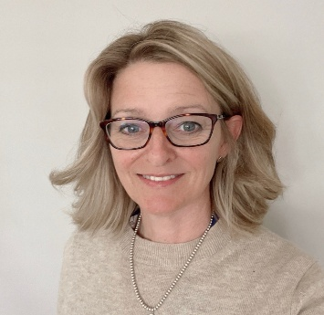

My vision is to create transformative experiences for every young person in our school and homes—places where autistic young people and those with complex needs are understood, valued, and supported to thrive. With extensive leadership experience across mainstream, specialist, and residential education, I bring a deep understanding of how to remove barriers, build strong teams, and shape environments where every learner can flourish. I am driven by a belief in personalised care, high aspirations, and the unique potential within every young person. Our total communication approach ensures that every child can find their voice—whether through speech, signing, symbols, AAC, or creative and sensory expression.
We strive to offer meaningful opportunities for choice, autonomy, and personal growth, supported by adults who champion each young person’s individuality. Many have faced barriers in the past; our compassionate and highly skilled teams help them overcome these challenges through strong relationships and therapeutic support woven into daily life. Through seamless collaboration between education and residential teams, progress is reinforced across all settings—helping our young people flourish, build purposeful relationships, and step confidently into their futures with pride, hope, and possibility.

The responsible individual
 | Mel McCarthy | Contact Details  Melissa McCarthy  Regional Lead  Paddocks View  Shillingstone  Blandford  Dorset, DT11 0QS  Email: Melissa.McCarthy@cambiangroup.com
My vision is to provide a wonderful and life-changing experience of care and education here at Riverstone View. Through maximising every opportunity for our young people to find their voice – be that verbal (own voice or through a device), using signs or symbols or through writing – we will help the young people here to exercise meaningful control and choice in their lives. My prior experience in education leadership, care and commerce, with full cooperation from the Cambian head office team, supports my role as Responsible Individual and Regional Care Lead to lead Riverstone View into a remarkable and dynamic future.

Developing effective communication skills and strategies will help our young people to overcome barriers of frustration, marginalisation and isolation leading to: active shared lives where people are supported to engage in an enjoyable and active life where likes and preferences are known and the young person can express their choices and preferences; enjoy independence in life, living in their community engaging in activities within their community; and with varying levels of support engage in employment – either voluntary or paid, with support or independently. I recognise that understanding individual need through careful assessment in our therapeutic environment guides how we seek to achieve the outcomes of each young person’s EHCP and our response to meet their individual need. Our multidisciplinary team has a brilliant range and depth with in-house SaLT, OT, Music Therapy, Physio, Psychologist, Psychiatrist, Equine Therapy and Clinical Lead Nurse. This team coordinates with education and care to ensure each area of our provision supports the young people here in the best possible ways.

I am delighted by our offer to the young people who live and learn at Riverstone View. We have a strong and truly capable adult team of carers, educationalists and therapies within a wonderful natural environment extending to 28 acres within peaceful Dorset countryside. It is a truly exceptional place to live, learn and work.

Head of Care

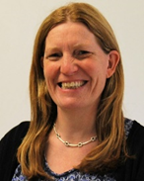 | Kerry Byron | Contact Details  Mrs Kerry Byron  Head of Care  Paddocks View  Shillingstone  Blandford Forum  Dorset  DT11 0QS  Email: Kerry.Byron@cambiangroup.com  Tel: 01258 860295
"I have worked at the school since 1999 and have been a Registered Manager since 2015. Previously, I worked in a large day school as a Teaching Assistant with children with various disabilities. Alongside this, I worked for social services as a support worker setting up and participating in Summer Activity Clubs.

I now oversee the children's homes within Riverstone View and am dedicated to working with our care adult team to support our children and young people to grow and develop. I fully appreciate that leaving a child in the trust of other adults is a challenging time for parents and therefore we strive to ensure that good relationships are built with all parents and work to ensure that key information is communicated to them.

I recognise and promote that for the majority of the year, if not all, this is the children's home and we are privileged to be a part of their childhood. We recognise that each and every child at the school needs care and nurturing and we work with them and parents to use individual strategies that best support their individual needs, thus striving to ensure they gain as much from their experience here as possible."

- Registered Manager
Mark Rogers | Contact Details  Mark Rogers  Registered Manager  Riverstone view  Shillingstone  Blandford  Dorset, DT11 0QS  Email: Mark.Rogers@cambiangroup.com

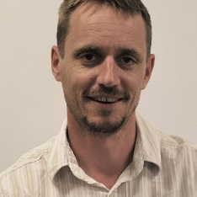

“I have worked in residential care settings since 1999 and have over 20 years of experience working with young people with an ASD diagnosis. My roles have included Support Worker, Assistant Team Manager, Team Manager, Care Manager and now Registered Manager.
I believe that the key to supporting our young people is to promote a sense of safety security and respect in a nurturing environment in which our young people feel listened too and able to express their views wishes and feelings to a team of adults who are responsive and empathic.
In order to be as independent as possible our young people need to be surrounded by adults who understand their needs but also have the skills to challenge the limitations that their diagnosis imposes in order to encourage personal growth and development for every individual in our care,

Details of the experience and qualifications of adult, including any adult commissioned to provide education or health care.
We endeavour to ensure that all adults allocated to young people are adequately experienced, trained and supported to deliver informed, quality care. Adults are expected to be qualified in the Diploma in Residential Childcare Level 3 or its equivalent: opportunity for enrolment on this aims to take place at the end of the probation period subject to Registered Managers discretion with a view to completion of this with the designated timeframe.

We ensure that all new adults complete a full induction programme and ‘shadow’ more experienced adults.

Full details of adult’s qualifications and experience are available as an appendix to this document

Details of the management and adult structure of the home, including arrangements for the professional supervision of adults, including adults that provide education or health care.
Dedicated adult teams work within each of the homes. A Home Manager (HM) will oversee the management of between one/two homes, depending on the number of young people and experience of the Home Manager. The Home Manager leads a team consisting of DHMs (Deputy Home Managers), SSWs (Senior Support Workers) and SWs (Support Workers). The number of adults allocated will depend on the size of the home and the needs of the young people. Home Managers and Deputy Home Managers provide supervision for their adult teams

Home Managers report to, and are supervised by the Registered Manager. The Senior Management team consists of Responsible Individual Registered Manager, Head of Care

Additional adults include the therapy team consisting of a Consultant Psychiatrist, a Clinical Psychologist and Assistant Psychologist, Speech and Language Therapist and Occupational Therapist.

Clinicians receive clinical supervision through their respective line managers . Details of qualifications for these adults are held on the homes data base which can be accessed on request.

The arrangements for supervision, training and development are as follows:

All employees have a job description that clearly defines what is expected of them. There is a supervision and appraisal process in place for all job roles.

The supervision sessions are arranged on a regular basis as per the Cambian Supervision Policy (for care adults, there is a minimum of nine sessions per year with the tenth session becoming an annual appraisal; however, there should be on average one session every six weeks with time allocated for this purpose. Supervision is a means of reflection and support, clarifying and seeking to assure that all aspects of role are performed to the expected standard of practice. It provides reassurance to the employee and is a forum for discussing pertinent issues and practice development. Targets are set and reviewed.

Performance monitoring and feedback during an employee’s six month (working weeks) probationary period is provided as an integral part of the supervision process. Appointments to all full-time and part-time posts are subject to a probationary period of six months (26 working weeks) unless the contract/statement of particulars of employment state otherwise.

During the probationary period the employee’s progress and suitability for the post is monitored and assessed against both the specific requirements of the Job Specification and other standards which can be reasonably expected by an employer. Formal meetings take place every four working weeks during this period culminating in a final meeting which confirms/terminates appointment or extends the period of probation.

Managers responsible for supporting probationers and other employees through the supervision process, assessing their suitability, are provided with the training necessary to carry this out. Supervisions of new adults on probation are provided can take the form of induction/mentoring or single subject supervision.

All employees participate in performance appraisal annually.

Appraisal meetings address standards required in key areas of the job description, strengths and achievements over the year, issues of concern and barriers to good performance, targets for future development and training and coaching needed to support development.

The Registered Manager monitors that all employees participate in supervision and appraisal or performance management as described in the policy. The Registered Manager oversees the home’s supervision log.

If the adult are all of one sex, or mainly of one sex, a description of how the home promotes appropriate role models of both sexes.
Adults are carefully blended in teams across Paddocks view. This enables an appropriate mix of adult genders and ages across all settings. All adults are trained and supported to act as positive role models.

CARE PLANNING:

Any criteria used for the admission of children to the home, including any policies and procedures for emergency admission.
Young people will be accepted to the home if aged between 7 and 19 years old with a primary diagnosis of autism but may also have secondary conditions such as, but not limited to, Attachment Disorder, Attention Deficit Hyperactivity Disorder (ADHD), Oppositional Defiant Disorder (ODD), Pathological Demand Avoidance (PDA), Anxiety, Obsessive Compulsive Disorder (OCD), Epilepsy and Diabetes.

Young people are accepted to Paddocks View when their identified and assessed needs can be met and they are compatible with the needs of the existing young people. Most young people will have an Education Health and Care Plan (EHCP).

The majority of individuals are placed by their local education authority and funding is also supported by Social Services, Health Care or a private contributor. The home has a range of placements from 38 week term time boarding and up to 52 week boarding. Within the education department there are places for day young people.

We do not accept emergency admissions.

Admissions can take place at any time during the year. Referrals and enquiries are made through the Cambian Admissions Team and can be made by parents, local authorities, social services departments or health authorities. Visits from prospective parents and representatives of placing authorities are always welcome and encouraged at any time. Children are admitted following a thorough assessment by members of the Senior Management Team and there is a detailed admissions policy outlining the process that can be viewed at the request of the referring person.

Admissions line: 0800 288 9779

Paddocks View is happy to provide any of the above-mentioned policies, an organisation chart and a school prospectus to parents and other stakeholders upon request.

Further Information:

Additional Contact Details

Dame Rachel De Souza
The Children’s Commissioner for England:
The Office of the Children's Commissioner
Sanctuary Buildings
20 Great Smith Street
London
SW1P 3BT

Tel: 020 7783 8330
cco.communications@childrenscommissioner.gov.uk

Child Protection Services:
Our Local Area Designated Officer Laura Taulk, Lynne Bowman and Martha Sharp Tel: 01305 221122
NSPCC child protection helpline Tel: 0808 800 5000 (adults)
Childline: Tel: 0800 1111

Independent Visitor/Listener:
Name: Julie Prior
Tel: NYAS National Advocacy Helpline 0808 808 1001.
Email: Julie.prior@nyas.net

